**ASSIGNMENT DAY 6 CYBER SECURITY ESSENTIALS**

**Question1:**

* Create payload for windows.
* Transfer the payload to the victim’s machine.
* Exploit the victim’s machine.

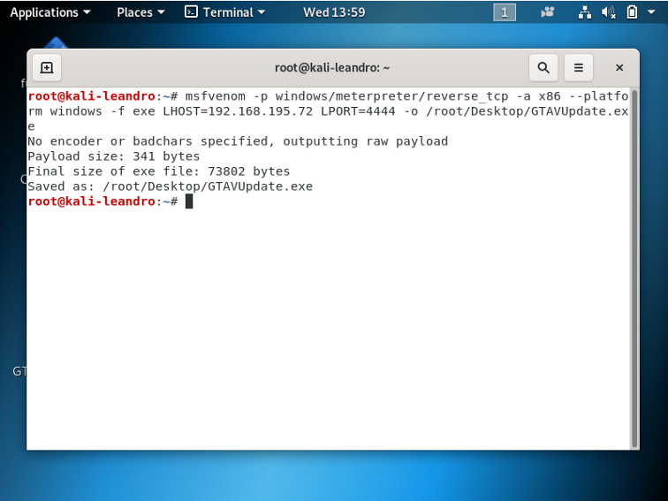

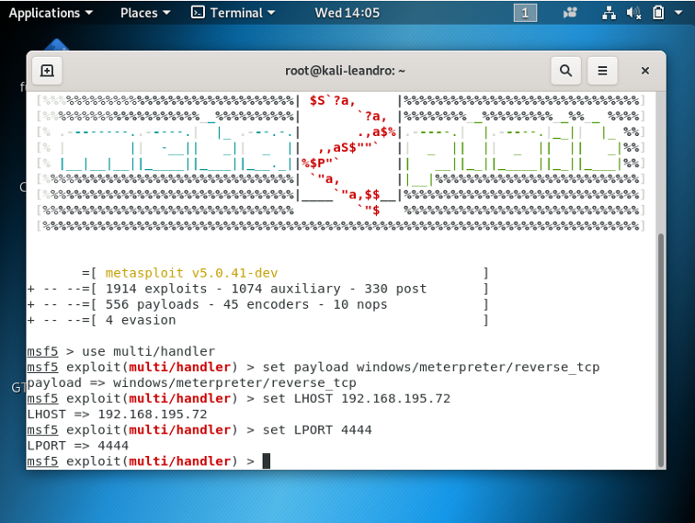

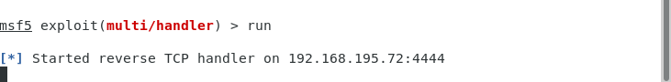

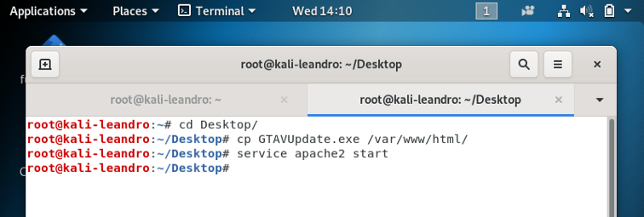

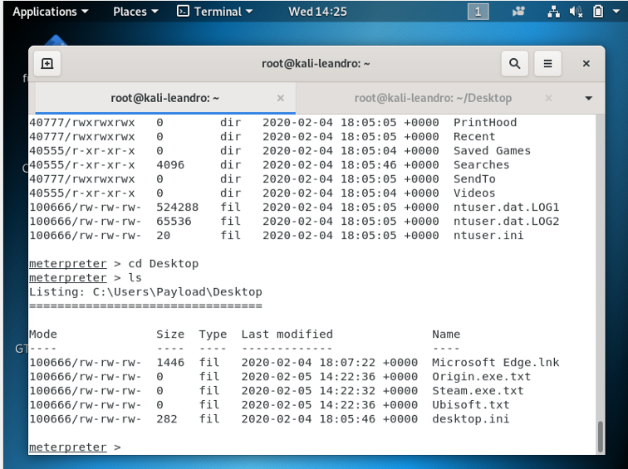

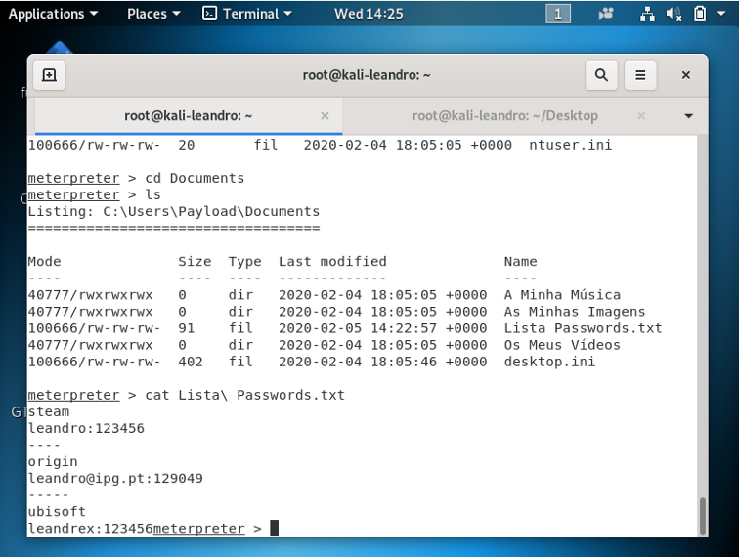

**Question2:**

* Create FTP server
* Access FTP server from windows command prompt
* Do an mitm and username and password of FTP transaction using wireshark and dsniff

